 |   Year 11 General Biology  Task 5 – Cells Processes

Name: | Teacher: | Date: | Score: /39

Assessment type: Test

Conditions

Time for the task: 50 minutes

Task weighting – 10%

Total 39 marks
__________________________________________________________________________

 | Section | Number of questions | Marks available | Marks achieved
A | Multiple choice | 11 | 11
B | Short answer | 5 | 20
C | Extended answer | 2 | 8
 | Total | 17 | 39

Part A: Multiple-choice (11 marks)

Section A consists of 11 questions, each worth one mark. Each question has only one correct answer.

- The cell membrane of living cells
- Protects, supports and gives shape to the cell
- Controls the flow of substances in and out of the cell
- Is the part of the cell where photosynthesis
- Supplies energy to all the other parts of the cell

- Which organelle is the site of cellular respiration?
- chloroplast
- golgi apparatus
- endoplasmic reticulum
- mitochondrion

- Where does gas exchange occur in animals?
- Left Broncus
- Trachea
- Alveoli
- Terminal Bronchiole

- Photosynthesis in green plants only occurs when the plant is in the light. When does respiration occur in green plants?
- Only in the dark
- At all times
- Only in the light
- When sufficient ATP is present

- Which of the following is not directly needed by plants for photosynthesis?
- carbon dioxide
- bacteria
- light
- water

- The green pigment in a plant is called ___________.
- Chlorophyll
- Chlorine
- Mitochondria
- Mesophyll

- What is the term that is best described as the diffusion of water through a selectively permeable membrane?
- Diffusion
- Osmosis
- Water transfer
- All of the above

- All of the following are parts of the equation for cellular respiration, EXCEPT
- glucose
- oxygen
- carbon dioxide
- ADP

Use the following diagram to answer questions 16 and 17.
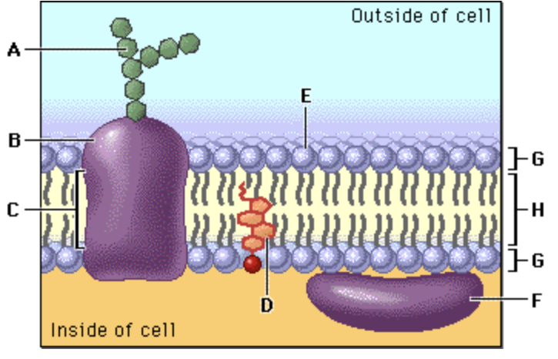

- In the diagram, structure E corresponds to:
- Protein
- Carbohydrate
- Lipid layer
- A hydrophilic structure

- In the diagram above, structure H corresponds to:
- A hydrophobic structure
- Cholesterol
- An integral protein
- A hydrophilic structure

- What is osmosis?
- Diffusion of water through a semi-permeable membrane
- When you take water out of a cell
- When you put water into the cell
- When you put water out the cell

END OF MULTIPLE CHOICE QUESTIONS

Part B: Short answer (20 marks)

Answer all questions in the spaces provided.

- Define the following

Active transport

Passive transport

- Describe how surface area to volume ratio can affect the rate of diffusion of different types of substances across membranes. (2 marks)

- Describe what has happened in the diagram below. (2 marks)
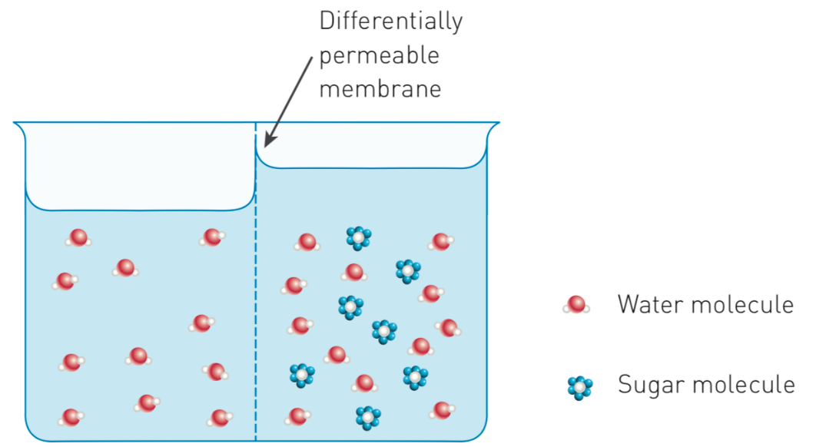

- The transportation of sugars and water within plants is essential for life. On the diagram of a tree below, use a blue pen to draw arrows to show the direction of water movement. Use a red pen to draw arrows to show the direction of sugar movement.
(1 mark)

- Photosynthesis is a series of chemical reactions catalyzed by enzymes that occurs in the chloroplasts of plant cells.

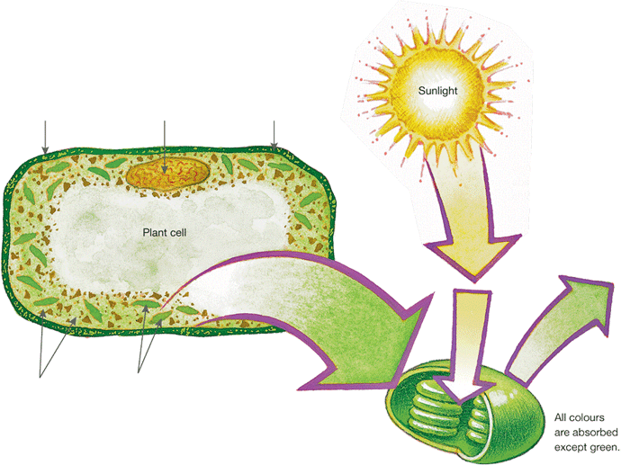
Identify the appropriate terms to label the figure below. (3 marks)

- Write a word equation for photosynthesis. (2 marks)

_________________________________________________________________________________

- Write a word equation for respiration. (2 marks)

_________________________________________________________________________________

- Write a chemical equation for respiration. (2 marks)

_________________________________________________________________________________

- A man was training for a 15 km fun run. He noticed that after 10 km his legs started to ache. Explain what is happening inside his muscle cells. (2 marks)

- What is the main difference between AEROBIC and ANAEROBIC respiration?
(2 marks)

END OF SHORT ANSWER QUESTIONS

Section C: Short Answer (8 marks)

Section C consists of 2 questions.
Write your answers in the spaces provided. You are advised to spend 10 minutes on this section.

1. A student set up the following experiment.

The experiment was left out on an open oval from 7:00 am to 5:00 pm on a sunny day. Explain the difference in the concentration of oxygen and carbon dioxide in the jars. (4 marks)

Oxygen concentration

Carbon dioxide concentration

2. The cells below are erythrocytes (red blood corpuscles). Varying amounts of sucrose were added to the extracellular environments A, B and C. Each of the three pictures depicts them in a different extracellular environment.
Describe fully the solutions and the processes that occur in the stages shown at A and C.
(4 marks )
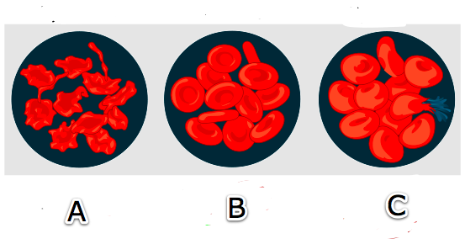

Stage A

Stage C

END OF TEST

